

**COURSE CODE: PGD004**

**COURSE NAME: POST GRADUATE DIPLOMA IN HUMAN NUTRITION**

**ASSIGNEMENT 1**

**STUDENT’S NAME: ORYEM JOSEPH PETER ACHIRE**

**AIPMS/226/002/2019**

**SUBMISSION DATE: 31th MAY, 2019**

**Question one.**

**Giving two examples for each, define the following terms:**

1. **Food**

The term ‘food’ refers to anything that we eat and which nourishes the body. It includes solids, semi-solids and liquids. Thus, two important features for any item to be called food are:

* It should be worth eating, that is, it should be ‘edible’.
* It must nourish the body.

Have you ever wondered why food is considered a basic necessity? It is essential because it contains substances which perform important functions in our body

The term 'food' brings to our mind countless images. We think of items not only that we eat and drink but also how we eat them and the places and people with whom we eat and drink. Food plays an important role in our lives and is closely associated with our existence. It is probably one of the most important needs of our lives.

The food that we eat is composed of small units that provide nourishment to the body. These are required in varying amounts in different parts of the body for performing specific functions. This means that good nutrition is essential for good health. However, if our diet provides the important units in incorrect amounts, either very less or in excess of what is required, it results in an imbalance of nutrients in your body. The condition is responsible for various deficiency diseases and slow or no growth of the body.

In this lesson you will learn about why food is essential, its functions and components. You will also be introduced to the terms like ‘nutrition’ and ‘nutrients’. After learning the meaning of these terms, you will then learn the sources and functions of the nutrients and the amounts required by different individuals.

1. **Nutrients**

Nutrient is defined as “a chemical substance obtained from food and used in the body to promote growth, maintenance, and repair of body tissues”, or simply as “a substance that provides nourishment”.

Broadly speaking, nutrients are classified into two groups, namely energy-producing nutrients (also called energy-providing nutrients or macronutrients) and micronutrients. Energy-providing nutrients include carbohydrates, fat and protein. Micronutrients often refer to vitamins and minerals

1. **Nutrition**

**Nutrition** is defined as the processes by which an animal or plant takes in and utilizes **food substances**. **Essential nutrients** include protein, carbohydrate, fat, vitamins, minerals and electrolytes.

All of us eat food. Food provides nourishment to the body and enables it to stay fit and healthy. The food that we eat undergoes many processes, like, first the food is digested, then it is absorbed into blood and transported to various parts of the body where it is utilized. The waste products and undigested food are excreted from the body.

**Question two.**

**Distinguish between dispensable and indispensable nutrients**

It is important to remember that the terms “indispensable” and “dispensable” were originally defined not only in dietary terms but also in relation to the role of amino acids in supporting protein deposition and growth. In fact, as far as I can ascertain, the original nutritional definition of an indispensable amino acid **(Borman et al. 1946)** was, “One which cannot be synthesized by the animal organism out of materials ordinarily available to the cells at a speed commensurate with the demands for normal growth.“

[Indispensable](http://dictionary.reference.com/browse/indispensable?s=t) nutrients (including amino acids) are those without which life is impossible. Indispensable nutrients that cannot be internally produced, but must be consumed from some external source, are called [essential](http://en.wikipedia.org/wiki/Essential_nutrient).

"Essential" is a scientific term of art in nutrition (i.e. it has a fixed, universally understood meaning); "indispensable" is not. As a result, the two are sometimes used interchangeably

Here, we compared the traditional nutritional definition of the dispensable and indispensable amino acids for humans with categorizations based on amino acid metabolism and function. The three views lead to somewhat different interpretations. From a nutritional perspective, it is quite clear that some amino acids are absolute dietary necessities if normal growth is to be maintained. Even so, growth responses to deficiencies of dispensable amino acids can be found in the literature. From a strictly metabolic perspective, there are only three indispensable amino acids (lysine, threonine and tryptophan) and two dispensable amino acids (glutamate and serine). In addition, a consideration of in vivo amino acid metabolism leads to the definition of a third class of amino acids, termed conditionally essential, whose synthesis can be carried out by mammals but can be limited by a variety of factors. These factors include the dietary supply of the appropriate precursors and the maturity and health of the individual. From a functional perspective, all amino acids are essential, and an argument in favor of the idea of the critical importance of nonessential and conditionally essential amino acids to physiological function is developed

**Question three.**

**Suggest a reason why protein deficiency/inadequacy would interfere with the process of digestion**

Protein deficiency is when your intake is unable to meet your body’s requirements. Dietary proteins perform a wide range of nutritional and biological functions. Amino acids are the building block of proteins and these Amino acids can be used by the body to form important cellular structures, such as **enzymes**, antibodies, **hormones**, muscle proteins, and collagen, Within the gastrointestinal tract (GIT), the level of protein has a major impact on digestion and absorption, and their digestive products affect several regulatory functions by interacting with receptors releasing hormones, affecting stomach emptying, gastrointestinal (GI) transport and absorption of nutrients (Leray et al., [2003](https://www.ncbi.nlm.nih.gov/pmc/articles/PMC5064168/#B18); Jahan-Mihan et al., [2011](https://www.ncbi.nlm.nih.gov/pmc/articles/PMC5064168/#B13); Yang et al., [2011](https://www.ncbi.nlm.nih.gov/pmc/articles/PMC5064168/#B35); He et al., [2016](https://www.ncbi.nlm.nih.gov/pmc/articles/PMC5064168/#B10)). So when there is inadequacy of this protein in the body, it may leads to low production of enzymes that help in digestion.

Enzymes act as catalysts in biochemical reactions, meaning that they speed the reactions up. Each enzyme recognizes one or more substrates, the molecules that serve as starting material for the reaction it catalyzes. Different enzymes participate in different types of reactions and may break down, link up, or rearrange their substrates.

One example of an enzyme found in your body is salivary amylase, which breaks amylose (a kind of starch) down into smaller sugars. The amylose doesn’t taste very sweet, but the smaller sugars do. This is why starchy foods often taste sweeter if you chew them for longer: you’re giving salivary amylase time to get to work.

**Question four.**

**Giving specific examples, explain what you understand by the term enzyme specificity.**

The ability of enzyme to bind with specific substrate or catalyze a specific set of chemical reactions, is called "Enzyme Specificity". Some enzymes have an intrinsic property of binding with only one substrate and catalysing a single reaction. This property is called "Absolute Specificity".E.g Urease enzyme acts on Urea.

One of the properties of enzymes that makes them so important as diagnostic and research tools is the specificity.

They exhibit relative to the reactions they catalyze.

A few enzymes exhibit absolute specificity; that is, they will catalyze only one particular reaction. Other enzymes will be specific for a particular type of chemical bond or functional group. In general, there are four distinct types of specificity:

* Absolute specificity - the enzyme will catalyze only one reaction.
* Group specificity - the enzyme will act only on molecules that have specific functional groups, such as amino, phosphate and methyl groups.
* Linkage specificity - the enzyme will act on a particular type of chemical bond regardless of the rest of the molecular structure.
* Stereo chemical specificity - the enzyme will act on a particular steric or optical isomer.

There is also an empirical measurement for specificity. The Specificity Constant.

Specificity constant measures the efficiency of an enzyme catalyzed reaction using a specific substrate. It is different from enzyme affinity because enzymes can have high affinity for ligands (e.g. inhibitors) but low catalytic efficiency. If the ligand doesn’t proceed through catalysis then it can hardly be called a specific substrate.

Specificity constant = kcat/Km

kcat = number of reactions per catalytic site per second (units are 1/s)

Km = which Michaelis-Menten constant and is also a measure of affinity.

Therefore the specificity constant incorporates the ability of an enzyme to perform a reaction and the enzymes affinity for the enzyme-substrate complex (ES).

If an enzyme catalyzes two competing reactions, their relative rates are determined by the concentrations of the competing substrates and the two specificity constants, i.e. the catalytic constants for the two substrates divided by the corresponding Michaelis constants. The concept of a specificity constant can be extended to reactions that require two or more substrates: in such cases the specificity for any competing substrate is determined by the apparent specificity constant measured at whatever concentrations of co-substrates, inhibitors, etc., exist under the conditions of competition. The partitioning between two competing substrates is independent of the concentration of any species, such as co-substrate, inhibitor, etc., that reacts only in the part of the mechanism that is common between the competing substrates.

**Question Five**

**a ). Explain what you understand by the term antinutrients.**

**Antinutrients** are natural or synthetic compounds that interfere with the absorption and metabolism of nutrients of other food sources or prevents the normal growth and development of an organism. Examples include the following:

Protease inhibitors (e.g., Bowman–Birk trypsin inhibitor in soybeans (Birk, 1985)), which inhibit trypsin, pepsin, and other proteases in the gut, preventing digestion and absorption of proteins and amino acids

Lipase inhibitors (e.g., tetrahydrolipstatin), which interfere with enzymes, such as lipases, which catalyze hydrolysis of some lipids and fats

Amylase inhibitors in beans, which prevent the action of enzymes that break the glycosidic bonds of starches and other complex carbohydrates, preventing the release of simple sugars and absorption by the body

Phytic acid in the hulls of nuts, seeds, and grains, which has a strong binding affinity for calcium, magnesium, iron, copper, and zinc, preventing their absorption

Oxalic acid and oxalates, which are present in many plants, particularly members of the spinach family, bind calcium to prevent its absorption

Many traditional preparation methods (e.g., fermentation) reduce antinutrients, such as phytic acid, increase the nutritional quality of plant foods, and are widely used in societies where cereals and legumes are a significant part of the diet (Reddy and Pierson, 1994). For example, cassava is fermented to reduce levels of both toxins and antinutrients. Glucosinolates (e.g., broccoli, Brussels sprouts, cabbage, and cauliflower), although widely recognized for their putative health benefits, also interfere with the uptake of iodine and flavonoids, and chelate metals (e.g., iron and zinc) thus reducing their absorption (Prakash et al., 2014).

**b). Explain three functions of bile in the digestion of lipids.**

Bile is a complex fluid containing water, electrolytes and a battery of organic molecules including bile acids, cholesterol, phospholipids and bilirubin that flows through the biliary tract into the small intestine.

**There are two fundamentally important functions of bile in all species:**

* Bile contains bile acids, which are critical for digestion and absorption of fats and fat-soluble vitamins in the small intestine.
* Many waste products, including bilirubin, are eliminated from the body by secretion into bile and elimination in feces.

Adult humans produce 400 to 800 ml of bile daily, and other animals proportionately similar amounts. The secretion of bile can be considered to occur in two stages:

* Initially, hepatocytes secrete bile into canaliculi, from which it flows into bile ducts. This hepatic bile contains large quantities of bile acids, cholesterol and other organic molecules.
* As bile flows through the bile ducts it is modified by addition of a watery, bicarbonate-rich secretion from ductal epithelial cells.

In species with a gallbladder (man and most domestic animals except horses and rats), further modification of bile occurs in that organ. **The gall bladder stores and concentrates bile during the fasting state.** Typically, bile is concentrated five-fold in the gall bladder by absorption of water and small electrolytes - virtually all of the organic molecules are retained.

Secretion into bile is a major route for eliminating cholesterol. Free cholesterol is virtually insoluble in aqueous solutions, but in bile, it is made soluble by bile acids and lipids like lecithin. [Gallstones](http://www.vivo.colostate.edu/hbooks/pathphys/digestion/liver/gallstones.html), most of which are composed predominantly of cholesterol, result from processes that allow cholesterol to precipitate from solution in bile.

**Role of Bile Acids in Fat Digestion and Absorption**

Bile acids are derivatives of cholesterol synthesized in the hepatocyte. Cholesterol, ingested as part of the diet or derived from hepatic synthesis is converted into the bile acids cholic and chenodeoxycholic acids, which are then conjugated to an amino acid (glycine or taurine) to yield the conjugated form that is actively secreted into cannaliculi.

Bile acids are facial amphipathic, that is, they contain both hydrophobic (lipid soluble) and polar (hydrophilic) faces. The cholesterol-derived portion of a bile acid has one face that is hydrophobic (that with methyl groups) and one that is hydrophilic (that with the hydroxyl groups); the amino acid conjugate is polar and hydrophilic.

Their amphipathic nature enables bile acids to carry out two important functions:

* **Emulsification of lipid aggregates:** Bile acids have detergent action on particles of dietary fat which causes fat globules to break down or be emulsified into minute, microscopic droplets. Emulsification is not digestion per se, but is of importance because it greatly increases the surface area of fat, making it available for digestion by lipases, which cannot access the inside of lipid droplets.
* **Solubilization and transport of lipids in an aqueous environment:** Bile acids are lipid carriers and are able to solubilize many lipids by forming **micelles** - aggregates of lipids such as fatty acids, cholesterol and monoglycerides - that remain suspended in water. Bile acids are also critical for transport and absorption of the [fat-soluble vitamins](http://www.vivo.colostate.edu/hbooks/pathphys/topics/vitamins.html).

**Role of Bile Acids in Cholesterol Homeostasis**

Hepatic synthesis of bile acids accounts for the majority of cholesterol breakdown in the body. In humans, roughly 500 mg of cholesterol are converted to bile acids and eliminated in bile every day. This route for elimination of excess cholesterol is probably important in all animals, but particularly in situations of [massive cholesterol ingestion](http://www.vivo.colostate.edu/hbooks/pathphys/digestion/liver/eateggs.html).

Interestingly, it has recently been demonstrated that [bile acids participate in cholesterol metabolism by functioning as hormones](http://www.vivo.colostate.edu/hbooks/pathphys/digestion/liver/bacid_hormones.html) that alter the transcription of the rate-limiting enzyme in cholesterol biosynthesis.

**Enterohepatic Recirculation**

Large amounts of bile acids are secreted into the intestine every day, but only relatively small quantities are lost from the body. This is because approximately 95% of the bile acids delivered to the duodenum are absorbed back into blood within the ileum.

Venous blood from the ileum goes straight into the portal vein, and hence through the sinusoids of the liver. Hepatocytes extract bile acids very efficiently from sinusoidal blood, and little escapes the healthy liver into systemic circulation. Bile acids are then transported across the hepatocytes to be resecreted into canaliculi. The net effect of this enterohepatic recirculation is that each bile salt molecule is reused about 20 times, often two or three times during a single digestive phase.

It should be noted that liver disease can dramatically alter this pattern of recirculation - for instance, sick hepatocytes have decreased ability to extract bile acids from portal blood and damage to the canalicular system can result in escape of bile acids into the systemic circulation. Assay of systemic levels of bile acids is used clinically as a sensitive indicator of hepatic disease.

**c). Explain how proteins differ structurally from carbohydrates and lipids.**

[Proteins](http://socratic.org/biology/molecular-biology-basics/proteins) are large molecules that consist of long chains of amino acids joined together by peptide (CONH) bonds.

**Explanation:**

**Proteins**

The structure of a small protein is

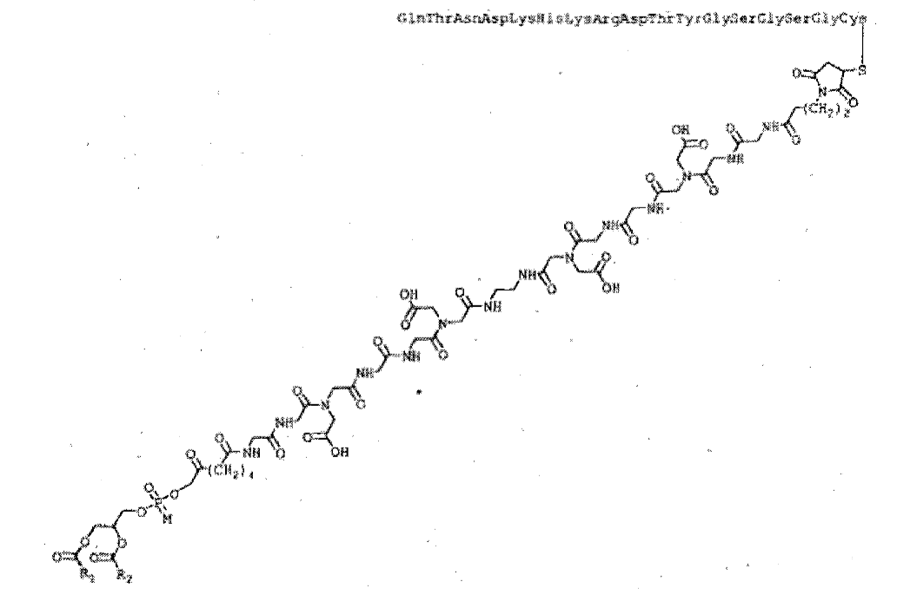patentimages.storage.googleapis.com

Proteins have polar C=O and N-H groups, so they are able to form hydrogen bonds with other molecules and with each other.

[**Carbohydrates**](http://socratic.org/biology/molecular-biology-basics/carbohydrates)

Carbohydrates have many polar OH groups.

A typical carbohydrate is starch, which is consists of many glucose units (C6H12O6) joined together.

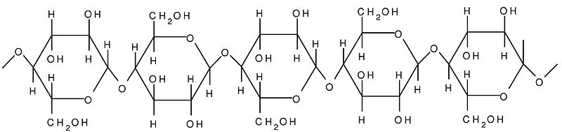upload.wikimedia.org

Most carbohydrates are **hydrophilic** and soluble in water because of their polar OH groups.

[**Lipids**](http://socratic.org/biology/molecular-biology-basics/lipids)

Lipids are **hydrophobic** and insoluble in water.

They have varied structures, but all have a polar "head" and a large nonpolar "tail"".

Fats and oils are typical lipids.

The structure of a typical fat is

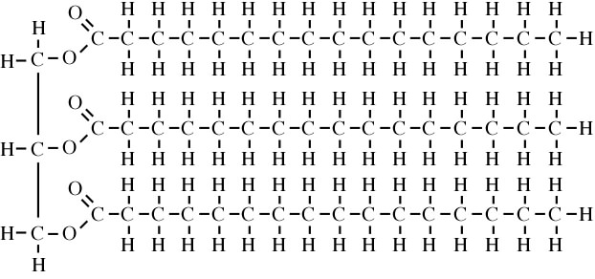www.indiana.edu

The molecule is mostly nonpolar hydrocarbon with some polar C=O groups at one end.

**REFERENCES**

1. *Albe KR, Butler MH, Wright BE.J Theor Biol. 1990 Mar 22; 143(2):163-95.*
2. Bennett, T. P., and Frieden, E.: Modern Topics in Biochemistry, pg. 43-45, Macmillan, London
3. Berg JM, Tymoczko JL, Stryer L. Biochemistry. 5th edition. New York: W H Freeman; 2002. Available from: <https://www.ncbi.nlm.nih.gov/books/NBK21154/>
4. [Biochemistry: Amino Acids are Precursors of Many Biomolecules](http://www.ncbi.nlm.nih.gov/books/NBK22446/)
5. Borman, A., Wood, T. R., Balck, H. C., Anderson, E. G., Oesterling, M. J., Womack, M. & Rose, W. C.(1946) The role of arginine in growth with some observations onthe effects of argininic acid. *J. Biol. Chem.*166:585–594
6. Cellular concentrations of enzymes and their substrates.
7. Cornish-Bowden A. Enzyme specificity: its meaning in the general case. J Theor Biol. 1984 Jun 7;108(3):451-7. PubMed PMID: 6748701.
8. Dwyer J. Harrisons Principles of Internal Medicine; Nutritional Requirements and Dietary Assessment. USA: The McGraw-Hill Companies; 2006.
9. food. BusinessDictionary.com. Retrieved April 14, 2019, from BusinessDictionary.com website: <http://www.businessdictionary.com/definition/food.html>
10. [*"food"*](https://www.britannica.com/topic/food). Encyclopedia Britannica. *[Archived](https://web.archive.org/web/20170727134023/https:/www.britannica.com/topic/food)*from the original on 2017-07-27*. Retrieved*
11. Harvard-MIT Division of Health Sciences and Technology HST.121: Gastroenterology, Fall 2005 Instructors: Dr. Martin C. Carey
12. https://www.quora.com/What-is-enzyme-specificity
13. https://socratic.org/questions/how-do-lipids-differ-from-carbohydrates-and-proteins
14. Jahan-Mihan A, Luhovyy BL, el Khoury D, et al. Dietary proteins as determinants of metabolic and physiologic functions of the gastrointestinal tract. Nutrients. 2011;3(5):574–603.
15. Leray V, Segain JP, Cherbut C, et al. Adaptation to low-protein diet increases inhibition of gastric emptying by CCK. Peptides. 2003;24(12):1929–1934.
16. Mann J et al. FAO/WHO Scientific update on carbohydrates in human nutrition: Conclusions. European Journal of Clinical Nutrition, 61(Suppl 1), S132–S137; 2007.
17. [**^**](https://encyclopedia.thefreedictionary.com/Antinutritional+factor#cite_ref-1) [***Oxford Dictionary of Biochemistry and Molecular Biology***](https://books.google.com/books?id=XpUjsqD7lFUC&pg=PA47). Oxford University Press, 2006. ISBN 0-19-852917-1.
18. Pfeiffer, J.: *Enzymes, the Physics and Chemistry of Life*, pg 171-173, Simon and Schuster, NY (1954)
19. Prakash, D. & Gupta, C. (2012). Glucosinolates: The Phytochemicals of Nutraceutical Importance. *Journal of Complementary and Integrative Medicine*, 9(1), pp. -. Retrieved 18 Apr. 2019, from doi:10.1515/1553-3840.1611
20. Reeds, Peter J.. “Dispensable and indispensable amino acids for humans.” The Journal of nutrition 130 7 (2000): 1835S-40S .
21. *Shahidi, Fereidoon (1997). Antinutrients and phytochemicals in food. Columbus, OH: American Chemical Society.*[***ISBN***](https://encyclopedia.thefreedictionary.com/International+Standard+Book+Number)*0-8412-3498-1.*
22. Williams' Essentials of Nutrition and Diet Therapy | 11th Edition
23. World Health Organization. Trace elements in human nutrition and health. Geneva: WHO; 1996.